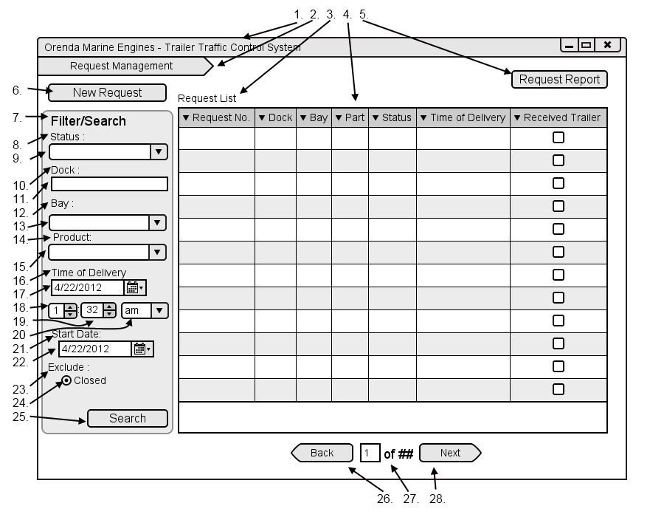

|  |  |  |  |
| --- | --- | --- | --- |
| # | Type | Text | Functions/Notes |
| 1 | Windows | Orenda Marine Engines – Trailer Traffic Control System | 800x600 |
| 2 | Breadcrumb |  | A list of all pages and subpages of the currently accessed page |
| 3 | Label | Request List |  |
| 4 | DataGrid |  | Fields: Dock, Bay, Foreman, Part, Status, Expected Deliver Time, Request Date  A list of all requests that match the currently selected search criteria |
| 5 | Button | Request Report | Displays the print report dialog |
| 6 | Button | New Request | Displays the dialog to create a new request |
| 7 | Label | Filter/Search |  |
| 8 | Label | Status |  |
| 9 | Selection box |  | List of all task statuses |
| 10 | Label | Dock: |  |
| 11 | Textbox |  | Dock textbox |
| 12 | Label | Bay: |  |
| 13 | Textbox |  | Bay textbox |
| 14 | Label | Product: |  |
| 15 | Textbox |  | Product Textbox |
| 16 | Label | Time of delivery |  |
| 17 | Date Picker |  | Time of delivery date picker |
| 18 | Selection Box |  | Numbers one through 12 |
| 19 | Selection Box |  | Numbers 1 through 59 |
| 20 | Selection box |  | Am / pm |
| 21 | Label | Start Date: |  |
| 22 | Date Picker |  | Start Dare Picker |
| 23 | Label | Exclude |  |
| 24 | Radio Button | Closed | Removes all closed requests if checked |
| 25 | Button | Submit | Filters the request list by the entered information |
| 26 | Button | Back | Move back one list of trailers, only visible if there are enough results to require multiple pages. |
| 27 | Label | ## of ## | Display the number based on the current page and the total pages |
| 28 | Button | Next | Move forward one list of trailers, only visible if there are enough results to require multiple pages. |

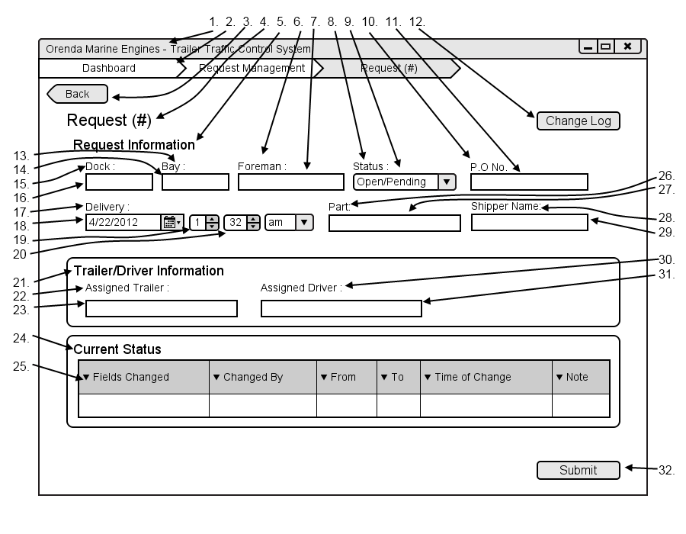

|  |  |  |  |
| --- | --- | --- | --- |
| # | Type | Text | Functions/Notes |
| 1 | Windows | Orenda Marine Engines – Trailer Traffic Control System | 800x600 |
| 2 | Breadcrumb |  | A list of all pages and subpages of the currently accessed page |
| 3 | Button | Back | Return to the Request Management |
| 4 | Label | Request (#) |  |
| 5 | Label | Request information |  |
| 6 | Label | Foreman: |  |
| 7 | Textbox |  | Foreman textbox |
| 8 | Label | Status: |  |
| 9 | Selection Box |  | List of all Statuses |
| 10 | Label | P.O No. |  |
| 11 | Textbox |  | P.O # textbox |
| 12 | Button | Change Log | Displays the Request change log screen |
| 13 | Label | Bay: |  |
| 14 | Textbox |  | Bay textbox |
| 15 | Label | Dock: |  |
| 16 | Textbox |  | Dock textbox |
| 17 | Date Picker |  | Time of delivery date picker |
| 18 | Selection Box |  | Numbers one through 12 |
| 19 | Selection Box |  | Numbers 1 through 59 |
| 20 | Selection box |  | Am / pm |
| 21 | Label | Trailer/Driver information |  |
| 22 | Label | Assigned Trailer: |  |
| 23 | Textbox |  | Assigned Trailer textbox |
| 24 | Label | Current Status |  |
| 25 | DataGrid |  | Fields: Fields Changed, Changed By, From, To, Time of Change, Note  Displays a list f all changes made to the request from is creation in reverse chronological order |
| 26 | Label | Part: |  |
| 27 | Textbox |  | Part textbox |
| 28 | Label | Shipper Name: |  |
| 29 | Textbox |  | Shipper Name textbox |
| 30 | Label | Assigned Driver: |  |
| 31 | Textbox |  | Assigned Driver textbox |
| 32 | Button | Submit | Submit changes made to the request |

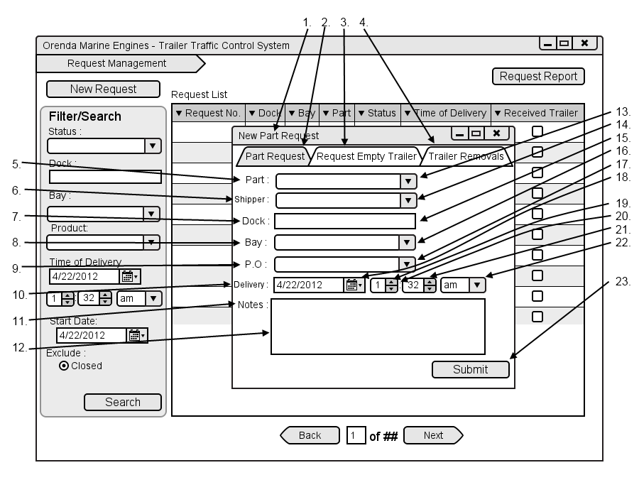

|  |  |  |  |
| --- | --- | --- | --- |
| # | Type | Text | Functions/Notes |
| 1 | Window | New Part Request |  |
| 2 | Tab Menu Item | Part Request |  |
| 3 | Tab Menu Item | Request Empty Trailer | Displays the Request Empty Trailer Options |
| 4 | Tab Menu Item | Trailer Removals | Displays the Trailer Removals Options |
| 5 | Label | Part: |  |
| 6 | Label | Shipper: |  |
| 7 | Label | Dock: |  |
| 8 | Label | Bay: |  |
| 9 | Label | P.O |  |
| 10 | Label | Delivery: |  |
| 11 | Label | Notes: |  |
| 12 | Textbox |  | Notes Textbox |
| 13 | Textbox |  | Part textbox |
| 14 | Textbox |  | Shipper textbox |
| 15 | Textbox |  | Dock textbox |
| 16 | Textbox |  | Bay textbox |
| 17 | Textbox |  | P.O textbox |
| 18 | Date Picker |  | Time of delivery date picker |
| 19 | Selection Box |  | Numbers one through 12 |
| 20 | Label | : |  |
| 21 | Selection Box |  | Numbers 1 through 59 |
| 22 | Selection box |  | Am / pm |
| 23 | Button | Submit | Submit the request and return them to the request list |

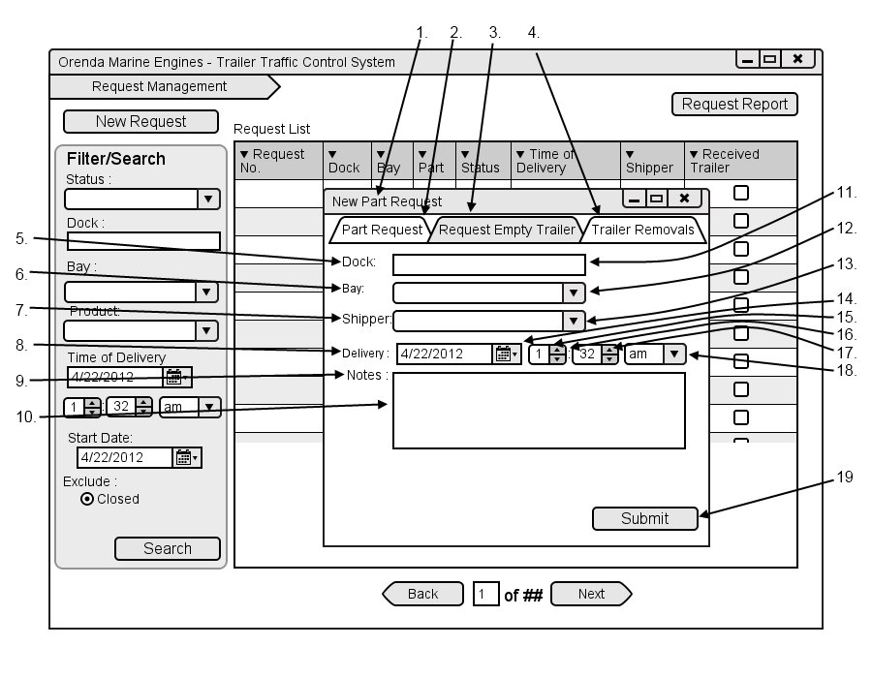

|  |  |  |  |
| --- | --- | --- | --- |
| # | Type | Text | Functions/Notes |
| 1 | Window | New Part Request |  |
| 2 | Tab Menu Item | Part Request | Displays the Part Request Options |
| 3 | Tab Menu Item | Request Empty Trailer |  |
| 4 | Tab Menu Item | Trailer Removals | Displays the Trailer Removals Options |
| 5 | Label | Shipper: |  |
| 6 | Label | Dock: |  |
| 7 | Label | Bay: |  |
| 8 | Label | Delivery: |  |
| 9 | Label | Notes: |  |
| 10 | Textbox |  | Notes Textbox |
| 11 | Textbox |  | Dock textbox |
| 12 | Textbox |  | Bay textbox |
| 13 | Textbox |  | Shipper textbox |
| 14 | Date Picker |  | Time of delivery date picker |
| 15 | Selection Box |  | Numbers one through 12 |
| 16 | Label | : |  |
| 17 | Selection Box |  | Numbers 1 through 59 |
| 18 | Selection box |  | Am / pm |
| 19 | Button | Submit | Submit the request and return them to the request list |

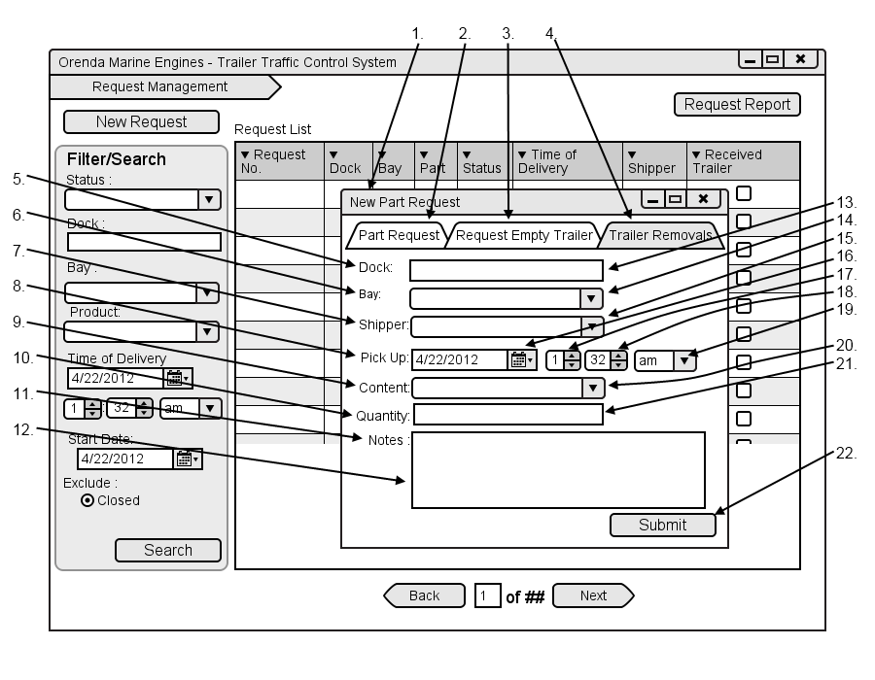

|  |  |  |  |
| --- | --- | --- | --- |
| # | Type | Text | Functions/Notes |
| 1 | Window | New Part Request |  |
| 2 | Tab Menu Item | Part Request | Displays the Part Request Options |
| 3 | Tab Menu Item | Request Empty Trailer | Displays the Request Empty Trailer Options |
| 4 | Tab Menu Item | Trailer Removals |  |
| 5 | Label | Dock: |  |
| 6 | Label | Bay: |  |
| 7 | Label | Shipper: |  |
| 8 | Label | Pick Up: |  |
| 9 | Label | Content: |  |
| 10 | Label | Quantity: |  |
| 11 | Label | Notes: |  |
| 12 | Textbox |  | Notes Textbox |
| 13 | Textbox |  | Dock textbox |
| 14 | Textbox |  | Bay textbox |
| 15 | Textbox |  | Shipper textbox |
| 16 | Date Picker |  | Time of delivery date picker |
| 17 | Selection Box |  | Numbers one through 12 |
| 18 | Selection Box |  | Numbers 1 through 59 |
| 19 | Selection box |  | Am / pm |
| 20 | Textbox |  | Content Textbox |
| 21 | Textbox |  | Quantity textbox |
| 22 | Button | Submit | Submit the request and return them to the request list |